

Swinburne University of Technology

Extension on mobile UX patterns

COS30017

Software Development for Mobile Devices

Marco Giacoppo (104071453)

Thursday 12:30

2023 Semester 2

# Introduction

Mobile UX patterns are crucial in determining how we interact with mobile apps and websites in our daily digital lives filled with smartphones and tablets. For designers and developers looking to improve user experiences on the smaller screens of our daily companions, these tried-and-true design solutions and interaction conventions—developed through extensive research—provide crucial guidance. To create user-friendly mobile interfaces that connect with today's tech-savvy users in their daily interactions, we will explore the fundamental elements and principles that form the basis of Mobile UX patterns throughout this journey.

## Pull-to-Refresh

The Pull-to-Refresh pattern allows users to update or reload content by dragging the screen downward and then releasing it, triggering a refresh action. This gesture provides a visually intuitive way for users to initiate content updates, making the user experience more efficient and engaging. It has become a widely recognized and expected interaction pattern in many mobile apps, contributing to the overall usability and convenience of the application.

**Pros:**

Pull-to-Refresh is an intuitive gesture that mimics the physical action of pulling down a piece of paper to see new content. This familiarity makes it easy for users to understand and use.

**Cons:**

While Pull-to-Refresh is intuitive for many users, it may not be immediately obvious to everyone, especially first-time users. Some users might need a tutorial to discover this feature.

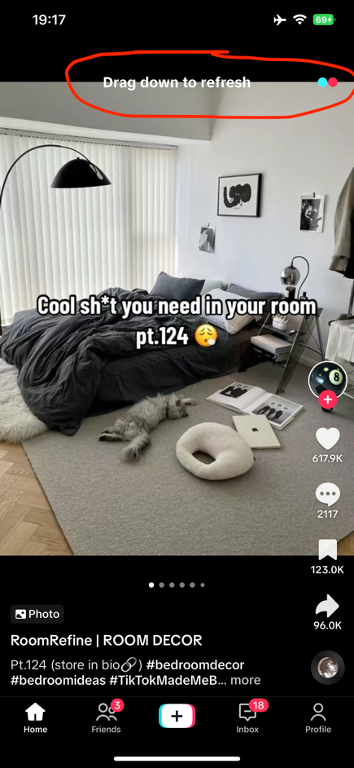

Figure : Pull-to-Refresh on TikTok

TikTok makes the Pull-to-Refresh pattern to update its feed seamlessly. Users can refresh their video feed by pulling down on the screen. As they pull, a refreshing animation appears along with a loading spinner, giving users real-time feedback. Once released, the feed updates, ensuring that users always have a stream of fresh, engaging content at their fingertips.

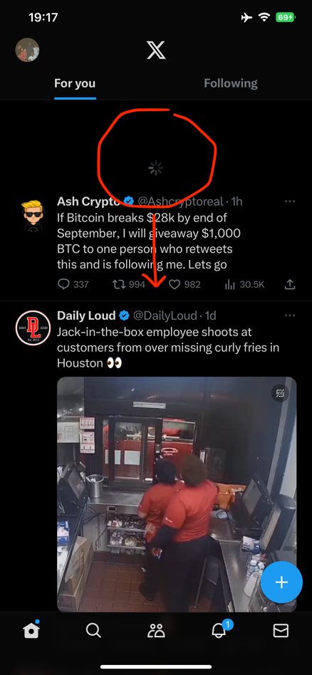

Figure : Pull-to-Refresh on Twitter / X

To keep its feed dynamic and up-to-date, Twitter also uses the Pull-to-Refresh pattern. Users are clearly instructed to release when the loading spinner and "Pull to refresh" message appear when they pull down their timeline. Users always have access to the most recent

tweets, news, and conversations in their feed thanks to this animation and sound effect.

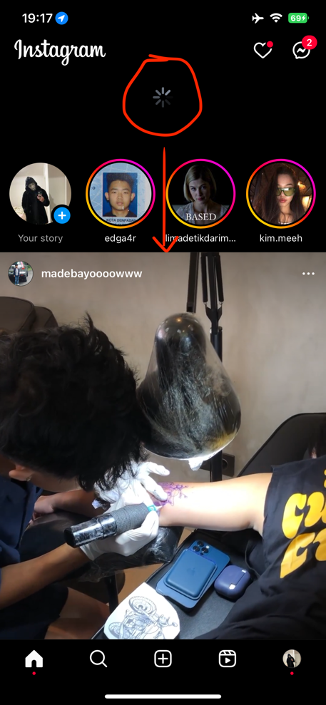

Figure : Pull-to-Refresh on Instagram

The Pull-to-Refresh pattern is essential to Instagram's user interface. Users can easily pull down on their home feed to view new posts and stories. A subtle loading animation and refresh icon appear as they proceed, indicating the update process. Users can easily stay up to date on the most recent posts from their friends and the accounts they follow thanks to the fluid, intuitive motion.

## Tab Bar Navigation

Tab bar navigation is a common mobile UX pattern featuring a row of labelled icons or tabs at the bottom of the screen, each representing a distinct section or feature of the app. Users can easily switch between these tabs with a tap, providing quick access to different app functionalities.

**Pros:**

Tab bar navigation offers straightforward and efficient navigation, reducing user effort in accessing key app areas. It provides clear visibility and context, making it ideal for apps with multiple core functions or content categories.

**Cons:**

However, space constraints at the bottom of the screen can limit the number of tabs, potentially requiring designers to prioritize features. In apps with many sections, it may lead to cluttered interfaces, requiring thoughtful design to maintain usability.

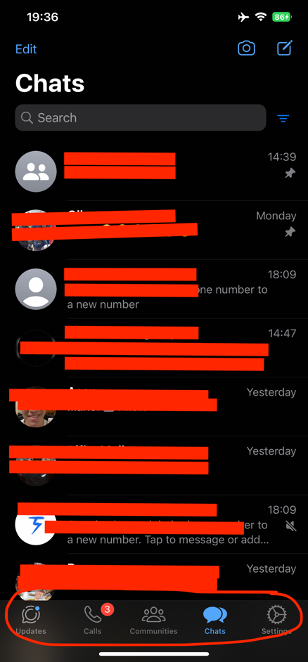

Figure 6: Tab Bar Nav on Facebook

Figure 5: Tab Bar Nav on WhatsApp

Figure 4: Tab Bar Nav on LinkedIn

**LinkedIn:**

LinkedIn utilizes the Tab Bar Navigation pattern to offer users a seamless experience when navigating through its professional networking platform. At the bottom of the screen, users can easily switch between tabs, including "Home," "My Network," "Post," "Notifications," and "Jobs." This intuitive navigation ensures quick access to key features, from connecting with professionals to job searching, all within a few taps.

**WhatsApp:**

WhatsApp adopts a simple and effective Tab Bar Navigation pattern in its user interface. At the bottom, users find tabs for "Updates," "Calls," "Communities," ”Chats,” and "Settings." This layout ensures that users can effortlessly transition between messaging, checking the status updates of contacts, making calls, and managing their account settings, offering a user-friendly and intuitive messaging experience.

**Facebook:**

Facebook employs the Tab Bar Navigation pattern as a fundamental part of its user interface. The app's tabs, located at the bottom, provides essential sections such as "Home," "Friends," "Video," "Marketplace," “Notifications,” and "Menu." By tapping on this tab, users can explore and engage with content, making it easy to stay conncted with friends, discover new content,

and interact with communities of interest.

## Floating Action Button (FAB)

The Floating Action Button (FAB) is a large, circular button that frequently appears in the bottom-right corner of an app, hovering above the main content. It acts as a convenient entry point into the app for a primary or high-priority action. The FAB's distinctive layout and placement make it simple for users to carry out important tasks like starting a new message, or getting directions.

**Pros:**

The FAB pattern provides a visually distinct and easily accessible point for essential actions, streamlining user interactions and reducing the need for navigating through menus. Its consistent placement across screens helps users quickly identify where to initiate important tasks, enhancing efficiency and engagement.

**Cons:**

However, overuse of the FAB can clutter the interface, potentially overwhelming users with too many options or actions. Careful consideration of which actions merit the FAB treatment is essential to prevent visual noise and maintain a clean and effective user interface.

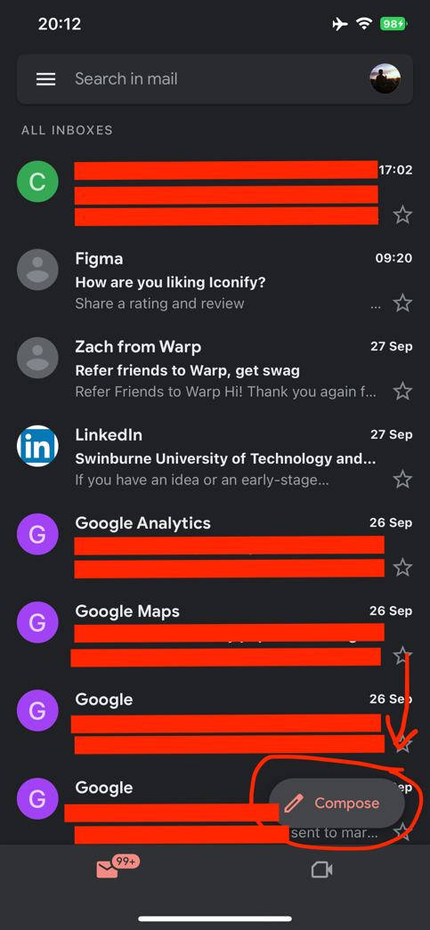

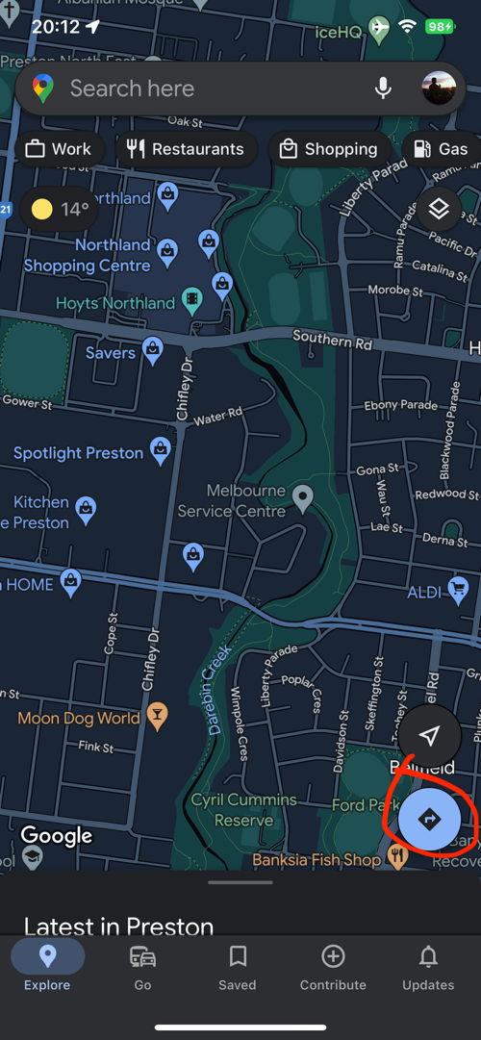

Figure 8: FAB on Gmail

Figure 7: FAB on Google Maps

**Google Maps:**

Google Maps features the Floating Action Button (FAB) at the bottom-right corner of its interface. This FAB serves as a central hub for users to initiate location-related actions. Tapping on it opens options for users to quickly start navigating to a destination. The FAB's presence ensures that users can effortlessly access the primary function of the app without navigating through multiple menus, enhancing the efficiency of their navigation experience.

**Gmail:**

In Gmail, the Floating Action Button (FAB) is a point for composing new emails. Located in the bottom-right corner of the inbox, it offers a one-tap solution for composing new messages. When tapped, the FAB opens an efficient email composition window, allowing users to effortlessly draft and send emails without having to navigate away from their inbox. This FAB design not only simplifies the email creation process but also maintains consistent placement for this essential action across different screens and email threads.

# Reference:

Anders Toxboe, & Anders Toxboe. (2020). *Design patterns*. Ui-Patterns.com. https://ui-patterns.com/patterns

*How do you keep your mobile app navigation up to date with the latest trends and user expectations?* (2023). Www.linkedin.com. https://www.linkedin.com/advice/0/how-do-you-keep-your-mobile-app-navigation-up-date#:~:text=Tab%20bars%20are%20simple%2C%20intuitive

*Material Design*. (n.d.). Material Design. https://m2.material.io/components/buttons-floating-action-button